

| **TITLE:**  Program to sort array |
| --- |

**AIM:** Program to sort a 1-D array in the ascending or descending order and then accept the element from the user and insert it in the same array at its correct place by keeping the array sorted. **______________________________________________________________________**

**Expected OUTCOME of Experiment:**

The program takes the number of elements in the array and each element in the array as the input, it then asks the user in what order the array is supposed to be outputted, i.e. ascending or descending. After the desired output is achieved it takes the value that is to be inserted in the array as the input and adjusts the array accordingly thus outputting a new array.

**_____________________________________________________________________**

**Books/ Journals/ Websites referred:**

1. Programming in C, second edition, Pradeep Dey and Manas Ghosh, Oxford University Press.
2. Programming in ANSI C, fifth edition, E Balagurusamy, Tata McGraw Hill.
3. Introduction to programming and problem solving, G. Michael Schneider, Wiley India edition.
4. [**http://cse.iitkgp.ac.in/~rkumar/pds-vlab/**](http://cse.iitkgp.ac.in/~rkumar/pds-vlab/)

**_____________________________________________________________________**

**Problem Definition:**

The program takes a 1D array and sorts it in the specified manner. The user enters an element and the same has to be inserted at the correct place in the sorted array.

**Flowchart:**

For ascending order:



For descending order:



For inserting a new element:



**Implementation details:**

#include<stdio.h>

void main()

{

int i,j,n,o,t,p,x,a[100];

printf("Enter the number of elements in the array: ");

scanf("%d",&n);

for(i=0;i<n;i++)

{

printf("Enter element no. %d of the array: ",i+1);

scanf("%d",&a[i]);

}

printf("1.Ascending order\n2.Descending order");

printf("\nChoose the order in which the array has to be displayed: ");

scanf("%d",&o);

switch(o)

{

case 1:

{

printf("Elements of the array in ascending order: ");

for(i=0;i<n;i++)

{

for(j=i+1;j<n;j++)

{

if(a[i]>a[j])

{

t=a[i];

a[i]=a[j];

a[j]=t;

}

}

printf("%d ",a[i]);

}

printf("\nEnter a new value that is to be inserted in the array: ");

scanf("%d",&x);

i=n-1;

while (x<a[i])

{

a[i+1]=a[i];

i--;

}

a[i+1]=x;

n++;

printf("After insertion the new array is: ");

for(i=0; i<n; i++)

{

printf("%d ",a[i]);

}

}

break;

case 2:

{

printf("Elements of the array in descending order: ");

for(i=0;i<n;i++)

{

for(j=i+1;j<n;j++)

{

if(a[i]<a[j])

{

t=a[i];

a[i]=a[j];

a[j]=t;

}

}

printf("%d ",a[i]);

}

printf("\nEnter a new value that is to be inserted in the array: ");

scanf("%d",&x);

i=n-1;

while (x>a[i])

{

a[i+1]=a[i];

i--;

}

a[i+1]=x;

n++;

printf("After insertion the new array is: ");

for(i=0; i<n; i++)

{

printf("%d ",a[i]);

}

}

break;

default:

{printf("Choose a valid option!");}

break;

}

}

**Output(s):**

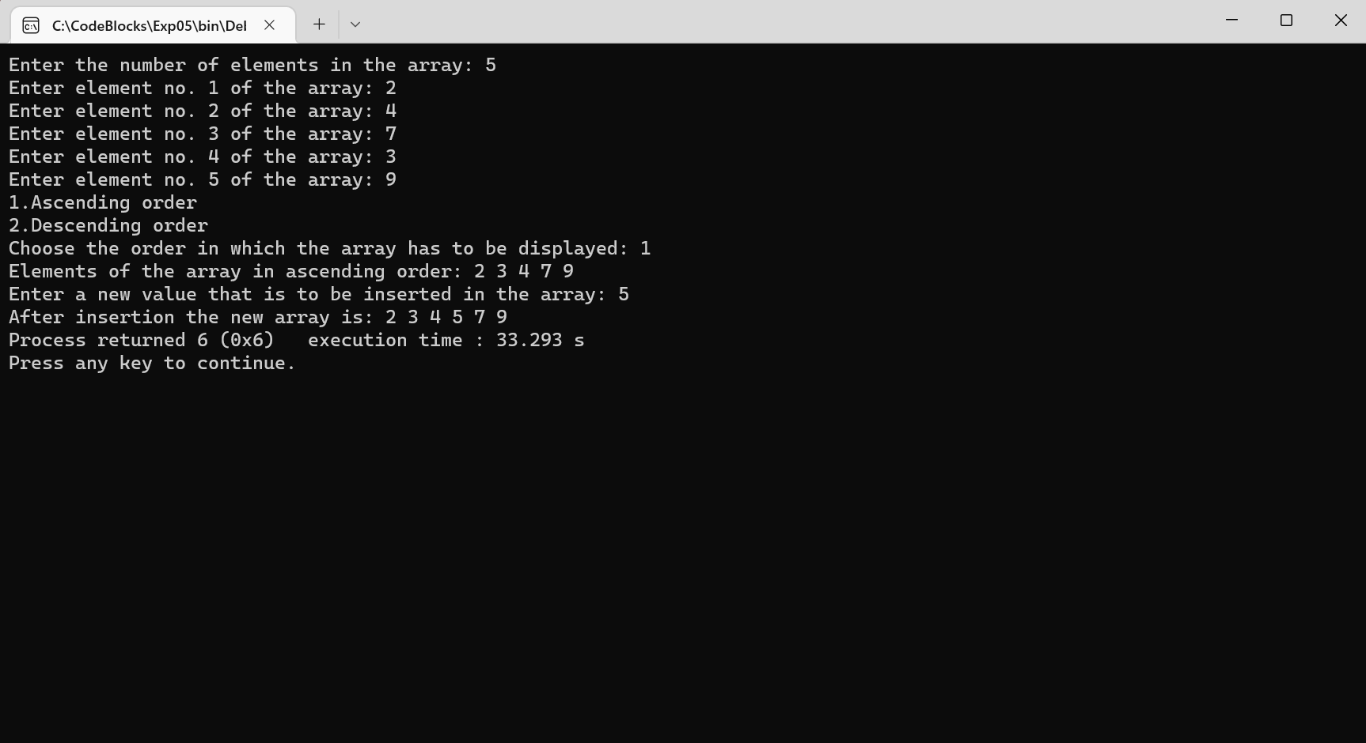

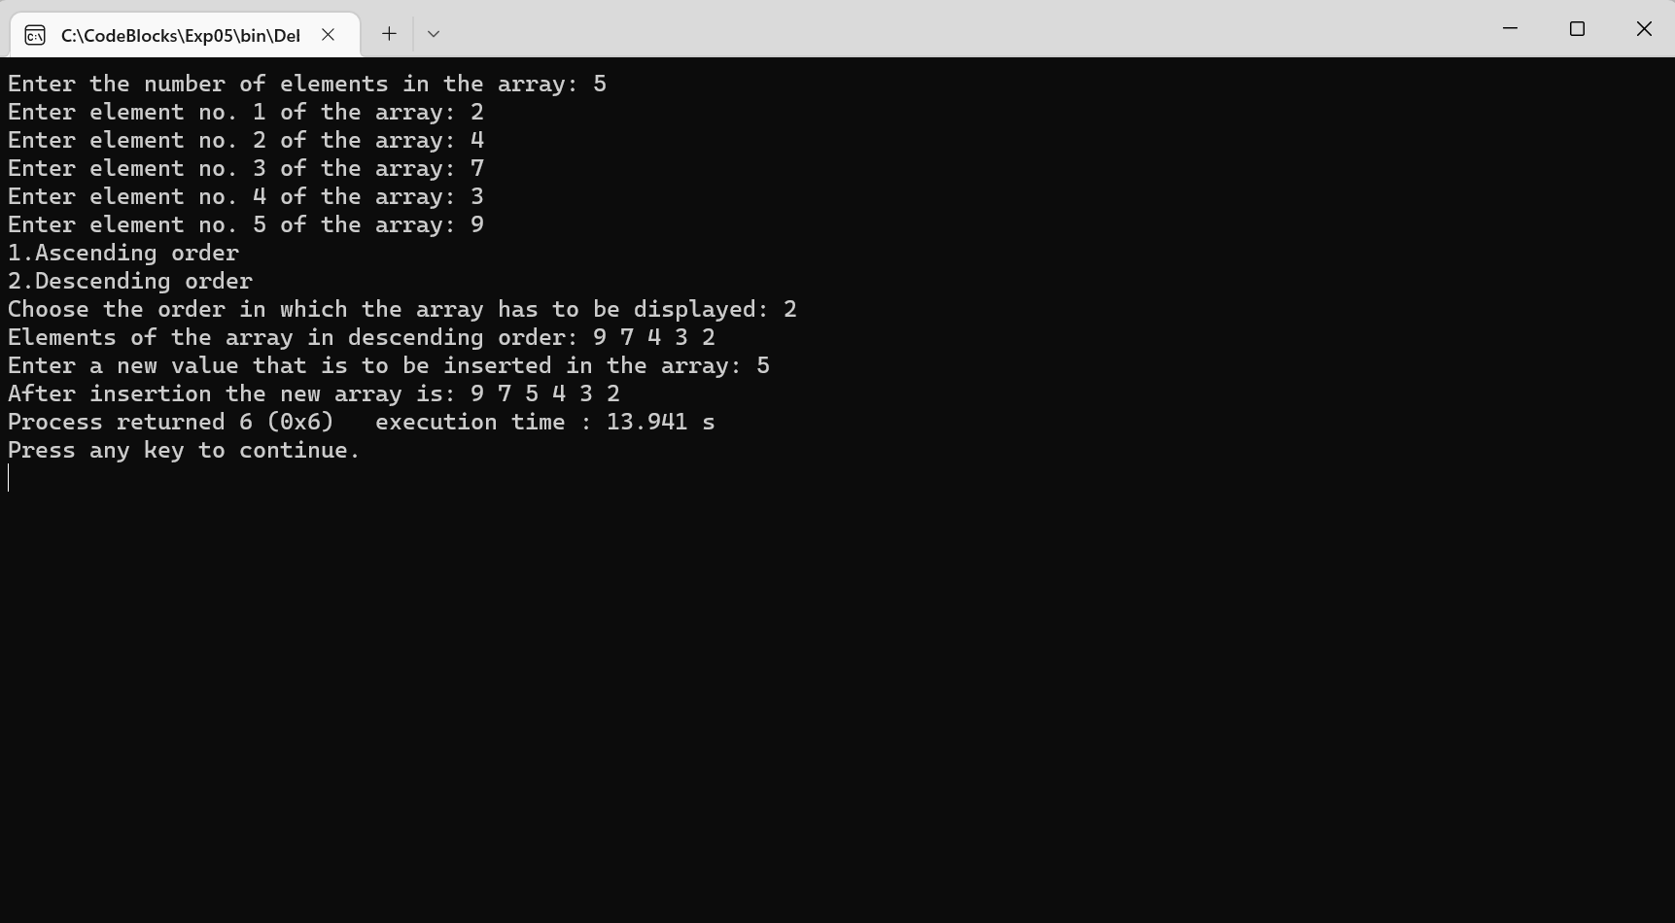

**Conclusion:**

The program takes the number of elements in the array and each element in the array as the input, it then asks the user in what order the array is supposed to be outputted, i.e. ascending or descending. After the desired output is achieved it takes the value that is to be inserted in the array as the input and adjusts the array accordingly thus outputting a new array.

**Post Lab Descriptive Questions**

Write a program to enter n numbers, store them in an array and rearrange the array in the reverse order.

Program:

#include<stdio.h>

void main()

{

int i,n,a[100];

printf("Enter the number of elements in the array: ");

scanf("%d",&n);

for(i=1;i<=n;i++)

{

printf("Enter the %d element of the array: ",i);

scanf("%d",&a[i]);

}

printf("The required array is: ");

for(i=1;i<=n;i++)

{

printf("%d ",a[i]);

}

printf("\nThe required reversed array is: ");

for(i=n;i>0;i--)

{

printf("%d ",a[i]);

}

}

Output:

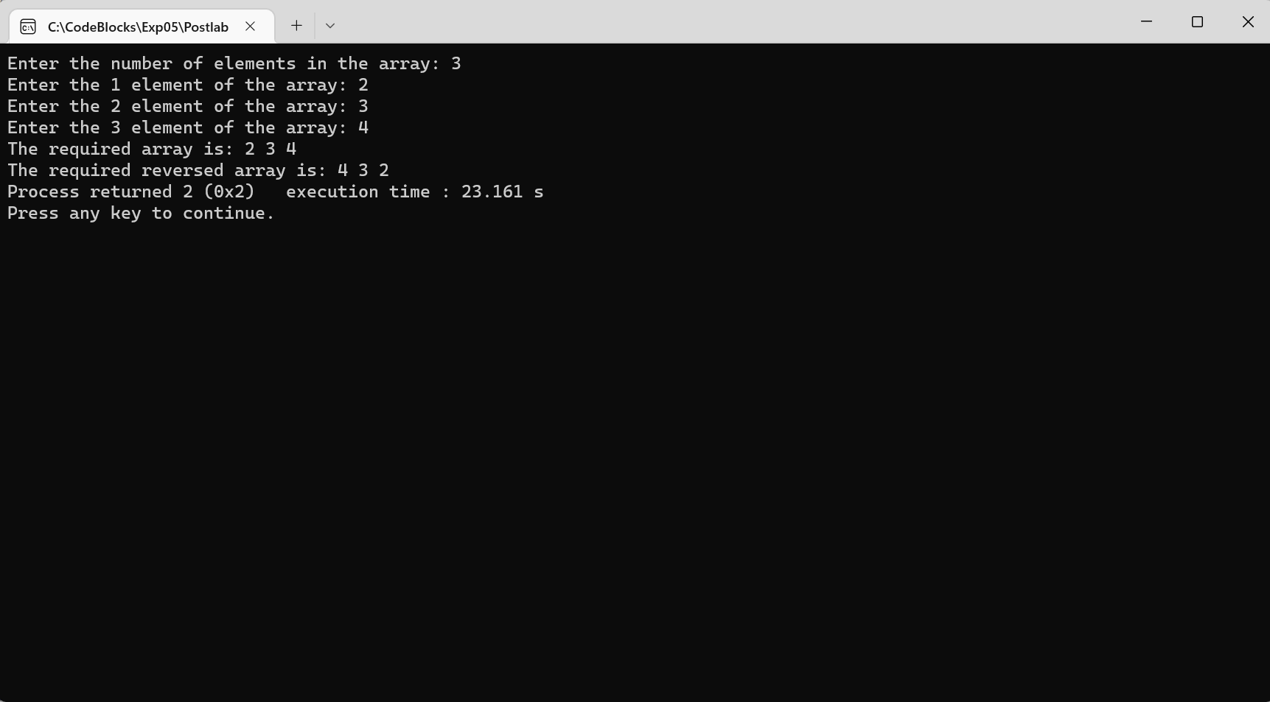

**Date: _____________ Signature of faculty in-charge**